Cielo Dorado HOA Owner/Contractor Requirements and Agreement to Indemnify

ALL CONTRACTORS MUST:

1-apply for their own gate codes for each project
2-provide porta-johns on site
3-provide barrier fencing around project
4-NOT ALLOW SEMI DUMP TRUCKS! (See photo below)
- No dump trucks larger than twin axle
- ONLY-Tandem Axle/9.5’ X 5.5’ X 3’/4-5.5 CY
- Absolutely no exceptions!
- A fine of $500 for each occurrence to the contractor
- A fine of $100 for each occurrence to the driver.
5-site activities to start no earlier than 7 am and must be ended by 5 pm
6-No Sat/Sun construction work unless approved by CDHA
- (Requests will be in writing at least 72 hours prior) $500 fine for each infraction.
7-over sized equipment trailers/specialty rig/extremely heavy trucks must use the West Gate off of
McNutt Rd.
8-Weight limit on paved surfaces is 12 tons.

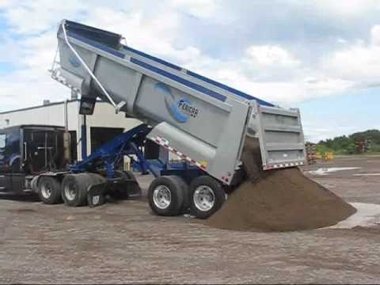
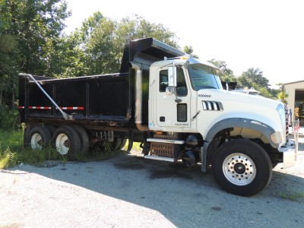
YES
NO

The undersigned owner and contractor hereby jointly agree to fully indemnify The Cielo Dorado HOA for any and all damages to Cielo Dorado property as a result of construction related activities, including but not limited to all roads, paved surfaces, gates, vegetation or other property which owners, contractor or sub-contractors’ damage. Owner and contractor are responsible for all sub-contractors and their employees.
If legal action is required to enforce this agreement the owner/contractor jointly agree they will be responsible for all court costs and attorneys fees, in addition to any damages caused to Cielo Dorado HOA property.

CONTRACTOR HOMEOWNER
Signature:_______________________________ Signature: ___________________________
Printed Name: ___________________________ Printed Name: _______________________
Company: ______________________________ Address: ___________________________
Date: _________________________________ Date: _____________________________

